**1. Introduction**

Keywords: Fuzzy Logic, Traffic Signal Control, Traffic Density, Traffic Flow Rate, Fuzzy Inference System, Cycle Length, MATLAB

Fuzzy Logic based Traffic Signal Control

**Md. Rakibul Hasan Rakib, Mustafuzur Rahman and Arbi Akther**

Computer Science and Engineering, State University of Bangladesh, Dhaka-1461,

Dhaka, Bangladesh; [rakib.sub.ug02@gmail.com,](mailto:rakib.sub.ug02@gmail.com,) [Mustafiz.sub.59019@gmail.com](mailto:Mustafiz.sub.59019@gmail.com)

**Abstract**

Traffic jams at intersections are a common problem in cities. Fixed-time traffic lights often fail to handle changing traffic flow, which leads to longer waiting times and congestion. This paper presents a traffic signal control system based on fuzzy logic. The system uses two input parameters, traffic density and traffic flow rate, to decide the cycle length of the signal. A fuzzy inference system is designed with suitable membership functions and rules to process these inputs. The model is tested using MATLAB Fuzzy Logic Toolbox, and the results show that the signal timing adjusts according to real traffic conditions. This approach can reduce vehicle delays and improve the efficiency of intersections compared to traditional fixed-time control.

Traffic jams at intersections waste time, fuel, and increase pollution. Fixed-time traffic lights cannot adjust to changing conditions, so sometimes empty roads get long green lights while crowded ones wait too long.

Fuzzy logic offers a better solution. It can handle uncertain or changing data, just like human reasoning. A fuzzy inference system (FIS) uses rules to connect traffic density and flow rate with the signal cycle length. By doing this, traffic lights can adapt in real time and reduce congestion more effectively than traditional fixed systems.

**1.1 Fuzzy Logic**

Proposed by Lotfi A. Zadeh in 1965, fuzzy logic extends traditional binary logic by allowing variables to take on values between 0 and 1. In everyday terms, it can describe situations that are not entirely true or false. For traffic control, this means the system can make decisions based on partial truth — for example,

a traffic density that is partly “medium” and partly “high.”

**1.2 Fuzzy Inference System (FIS)**

A Fuzzy Inference System is the “brain” of a fuzzy logic controller. It works in four steps:

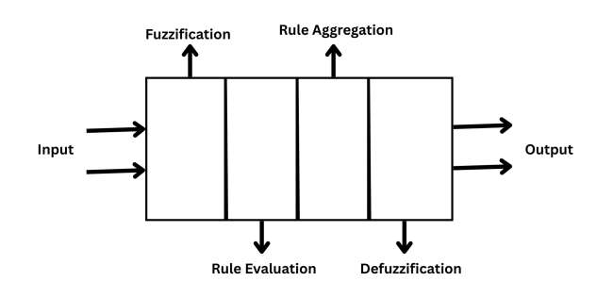

Figure 1. Fuzzy Inference System (FIS)

* Fuzzification – Convert real-world measurements (like cars/hour) into fuzzy terms (like low, medium, high) using membership functions.
* Rule Evaluation – A set of IF–THEN rules that describes expert knowledge.  
  Example: IF traffic density is high AND traffic flow is high, THEN green time is long.
* Rule Aggregation – Decides which rules apply based on current inputs.
* Defuzzification – Converts fuzzy results into a single real output (like 42 seconds of green light).

1. **Problem Description**

Fixed-time traffic lights do not adjust to real traffic, causing long waits and congestion. The proposed system uses fuzzy logic with two inputs—traffic density and traffic flow rate—to decide the signal cycle length. This makes the light timing flexible and better suited to actual traffic conditions.

* 1. **Working Principle**

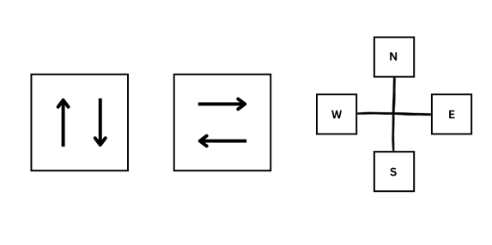

Figure 2. Phases considered in fuzzy traffic signal control.

The system is designed for a four-way intersection where traffic comes from the North, South, East, and West. For simplicity:

* No left or right turns are considered.
* Pedestrian crossings are not included.
* Traffic is split into two phases:
  + Phase 1: North–South movement
  + Phase 2: East–West movement

Two sensors are placed on each approach:

* The first sensor, located near the signal, counts vehicles passing through.
* The second, placed 200 meters before the signal, counts approaching vehicles.

The data from these sensors provide two main input values: traffic density and traffic flow rate. The output is the cycle length — the total time for a complete green–yellow–red cycle.

**2.2. Inputs and Output**

Input 1: Traffic Density (vehicles/km)  
This represents the number of vehicles on a stretch of road.

Formula:



Example: If 20 cars are on 0.5 km, then density = 40 vehicles/km.

Input 2: Traffic Flow Rate (vehicles/hour)  
This is the rate of vehicles passing through a point in one hour.  
Formula:



Example: Density = 40 vehicles/km, Speed = 30 km/h → Flow Rate = 1200 vehicles/hour.

Output: Cycle Length (seconds)  
This is the total time for one complete cycle of green–yellow–red lights. Instead of keeping it constant, the fuzzy logic system changes it depending on the density and flow rate measured

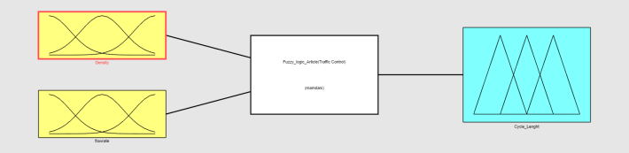

Figure 3. Fuzzy logic based traffic signal controller.

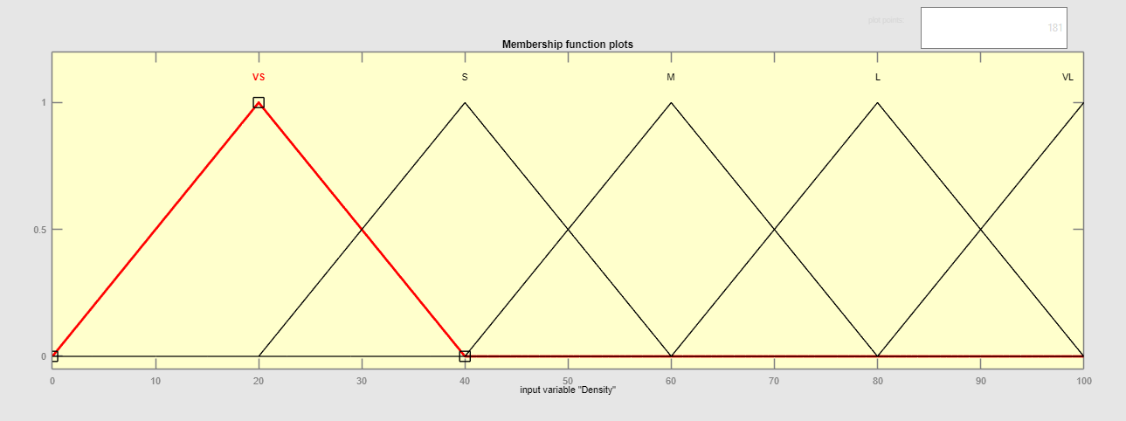

Figure 4. Membership functions for traffic density.

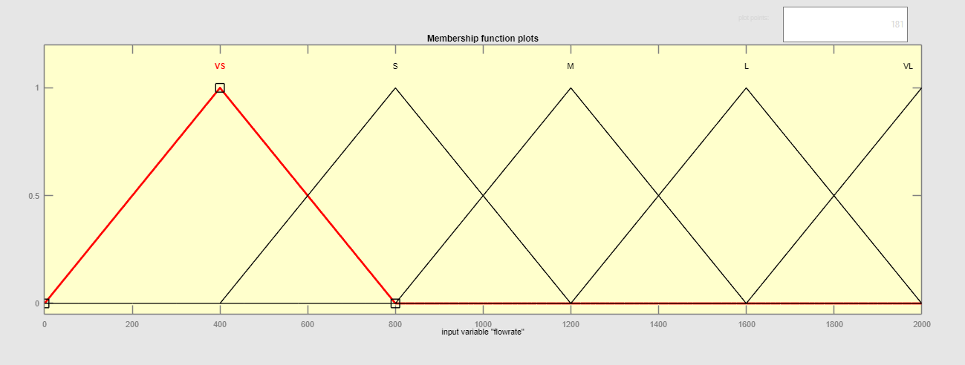

Figure 5. Membership functions for traffic flow

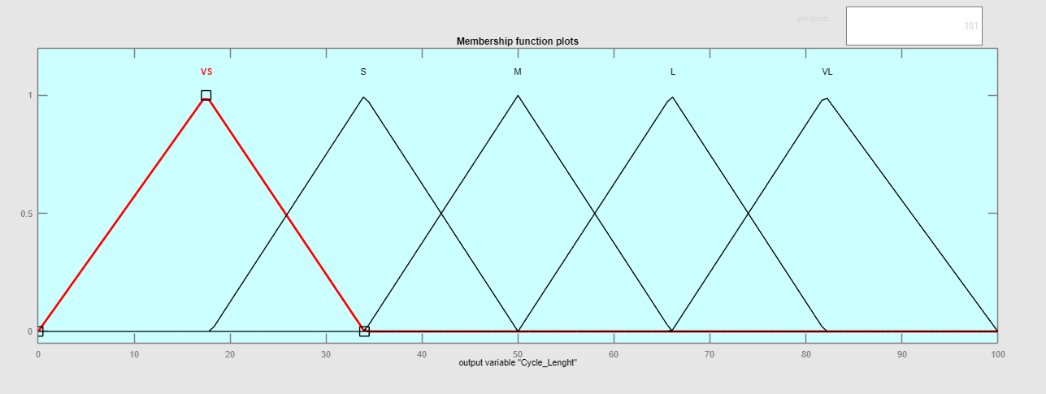

Figure 6. Membership function for cycle length.

**3. Fuzzy Rules**

The decision-making uses 25 rules, covering all combinations of:

* Traffic Density: Very Small (VS), Small (S), Medium (M), Large (L), Very Large (VL)
* Traffic Flow Rate: VS, S, M, L, VL

**Rules :**

1. IF Density is Very Small (VS) AND Flow is Very Small (VS) THEN Cycle Length is Very Small (VS)
2. IF Density is VS AND Flow is Small (S) THEN Cycle Length is Small (S)
3. IF Density is VS AND Flow is Medium (M) THEN Cycle Length is Small (S)
4. IF Density is VS AND Flow is Large (L) THEN Cycle Length is Medium (M)
5. IF Density is VS AND Flow is Very Large (VL) THEN Cycle Length is Large (L)
6. IF Density is Small (S) AND Flow is VS THEN Cycle Length is Very Small (VS)
7. IF Density is S AND Flow is S THEN Cycle Length is Small (S)
8. IF Density is S AND Flow is M THEN Cycle Length is Small (S)
9. IF Density is S AND Flow is L THEN Cycle Length is Medium (M)
10. IF Density is S AND Flow is VL THEN Cycle Length is Large (L)
11. IF Density is Medium (M) AND Flow is VS THEN Cycle Length is Small (S)
12. IF Density is M AND Flow is S THEN Cycle Length is Small (S)
13. IF Density is M AND Flow is M THEN Cycle Length is Medium (M)
14. IF Density is M AND Flow is L THEN Cycle Length is Medium (M)
15. IF Density is M AND Flow is VL THEN Cycle Length is Large (L)
16. IF Density is Large (L) AND Flow is VS THEN Cycle Length is Small (S)
17. IF Density is L AND Flow is S THEN Cycle Length is Medium (M)
18. IF Density is L AND Flow is M THEN Cycle Length is Medium (M)
19. IF Density is L AND Flow is L THEN Cycle Length is Large (L)
20. IF Density is L AND Flow is VL THEN Cycle Length is Large (L)
21. IF Density is Very Large (VL) AND Flow is VS THEN Cycle Length is Very Small (VS)
22. IF Density is VL AND Flow is S THEN Cycle Length is Small (S)
23. IF Density is VL AND Flow is M THEN Cycle Length is Medium (M)
24. IF Density is VL AND Flow is L THEN Cycle Length is Large (L)
25. IF Density is VL AND Flow is VL THEN Cycle Length is Very Large (VL)

**4. Output from Fuzzy Logic Toolbox**

The system was implemented using MATLAB’s Fuzzy Logic Toolbox

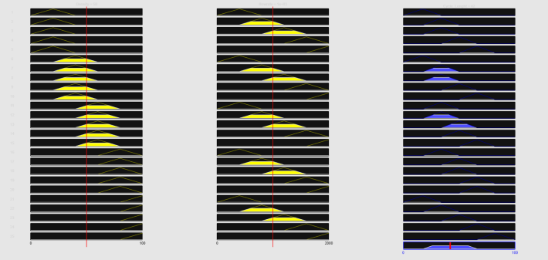

Figure 7. Surface plot of rules.

**4.1. Membership Functions**

* Traffic Density: Five triangular membership functions covering 0–100 vehicles/km.
* Traffic Flow Rate: Five triangular membership functions covering 0–2000 vehicles/hour.
* Cycle Length: Five triangular membership functions covering 0–100 seconds.

**4.2. Simulation Results**

Using the MATLAB Rule Viewer:

* Low density (VS) + low flow (VS) → short cycle (~16 seconds)
* Medium density (M) + medium flow (M) → medium cycle (~40 seconds)
* Very large density (VL) + very large flow (VL) → long cycle (~66 seconds)

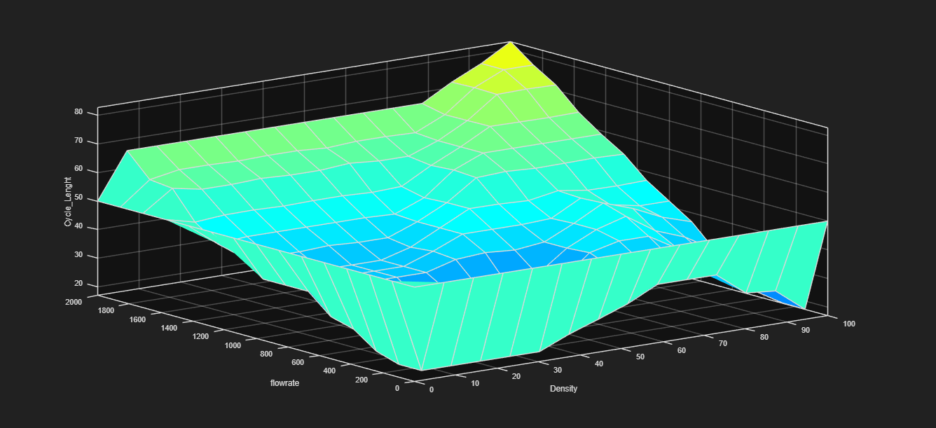

Figure 8. Surface Viewe 3D curve.

The Surface Viewer shows a smooth 3D curve where the cycle length increases with either higher density or higher flow, reaching maximum values when both are high.

**5. Conclusion**

This fuzzy logic–based traffic signal control system adjusts signal timings dynamically, responding to real-time traffic conditions. It offers several advantages over fixed-time systems:

* Reduced waiting times for vehicles
* Better utilization of road capacity
* Improved handling of fluctuating traffic volumes

The performance of the system depends on well-designed membership functions and carefully tuned rules. Future work could include expanding the system to coordinate multiple intersections, adding pedestrian phases, or integrating IoT-based sensors for more precise traffic measurement.

1. **References**
2. L. A. Zadeh, “Fuzzy sets” Information and Control, vol. 8, no. 3, pp. 338–353, 1965. doi: 10.1016/S0019-9958(65)90241-X.
3. E. H. Mamdani, “Application of fuzzy algorithms for control of simple dynamic plant,” Proceedings of the Institution of Electrical Engineers, vol. 121, no. 12, pp. 1585–1588, Dec. 1974. doi: 10.1049/piee.1974.0328.
4. N. Sharma and S. Sahu, “Fuzzy logic based traffic signal control,” Indian Journal of Science and Technology, vol. 11, no. 23, pp. 1–6, Jun. 2018, doi: 10.17485/ijst/2018/v11i23/114380.
5. B. P. Gokulan and D. Srinivasan, “Distributed geometric fuzzy multi-agent urban traffic signal control,” IEEE Transactions on Intelligent Transportation Systems, vol. 11, no. 3, pp. 714–727, Sept. 2010. doi: 10.1109/TITS.2010.2050688.
6. P. G. Balaji and D. Srinivasan, “Type-2 fuzzy logic based urban traffic management,” IEEE Computational Intelligence Magazine, vol. 5, no. 4, pp. 43–51, Nov. 2010. doi: 10.1109/MCI.2010.938755.
7. F. Qiao, P. Yi, H. Yang, and S. Devarakonda, “Fuzzy logic based intersection delay estimation,” Mathematical and Computer Modelling, vol. 36, no. 11–13, pp. 1425–1434, Dec. 2002. doi: 10.1016/S0895-7177(02)90224-7.
8. M. H. F. Zarandi, S. M. H. Hosseini, and I. B. Turksen, “A hybrid fuzzy agent-based model for urban traffic systems,” Transportation Research Part C: Emerging Technologies, vol. 19, no. 5, pp. 890–903, Oct. 2011. doi: 10.1016/j.trc.2011.03.004.
9. MathWorks, “Fuzzy Logic Toolbox™ User’s Guide,” 2024. [Online]. Available: https://www.mathworks.com/help/fuzzy